**MOCK EXAMINATIONS 2016**

**456/1 MATHEMATICS PAPER ONE**

**2 HOURS 30 MINUTES.**

**INSTRUCTIONS TO CANDIDATES:**

**Answer all questions in section A and any five questions from section B.**

**Any additional questions (s) answered from section b will not be marked.**

**All necessary calculations must be done on the same page as the rest of the answer. No paper should be given for rough work.**

**Graph Paper is provided.**

**Silent, non-programmable scientific calculators and mathematical tables may be used.**

**SECTION A (40 MARKS)**

**ATTEMPT ALL QUESTIONS IN THIS SECTION**

1. Given that m*n = m²-3n², evaluate
2. 9 *-5
3. (9*-5) * 2

**4marks**

1. Solve the inequality 3(2x-1) ≤5x+2 and hence show the solution on a number line. **4marks**
2. Use factorization method to solve the quadratic equation 2x²-4x – 30 = 0

**4marks**

1. Given that matrix $p=\left(\begin{aligned}-4 3 \\ 2 1\end{aligned}\right)$, find Pˉ¹ the inverse of P
2. Solve for x in the equation

$\frac{x-1}{3}$ − $\frac{3-2x}{5}$ = $\frac{x}{2}$

**4 marks**

1. The numbers 5, 6 and 7 are arranged in a random order to form a three digit number. If no digit is repeated in any number formed;

(a). Write down the possibility space for the numbers formed.

(b) Find the probability that the number formed is an even number

**4marks**

1. By using Matrix method, solve the simultaneous equations:

4x – y = 9

3x + 2y = 4 **4marks**

1. Make b the single subject in the equation: 4marks

p= $\sqrt{\frac{a-5b}{b-c}}$

1. In the figure below, O is the centre of the circle, angle OAB=20˚ and obtuse angle AOC =120˚.

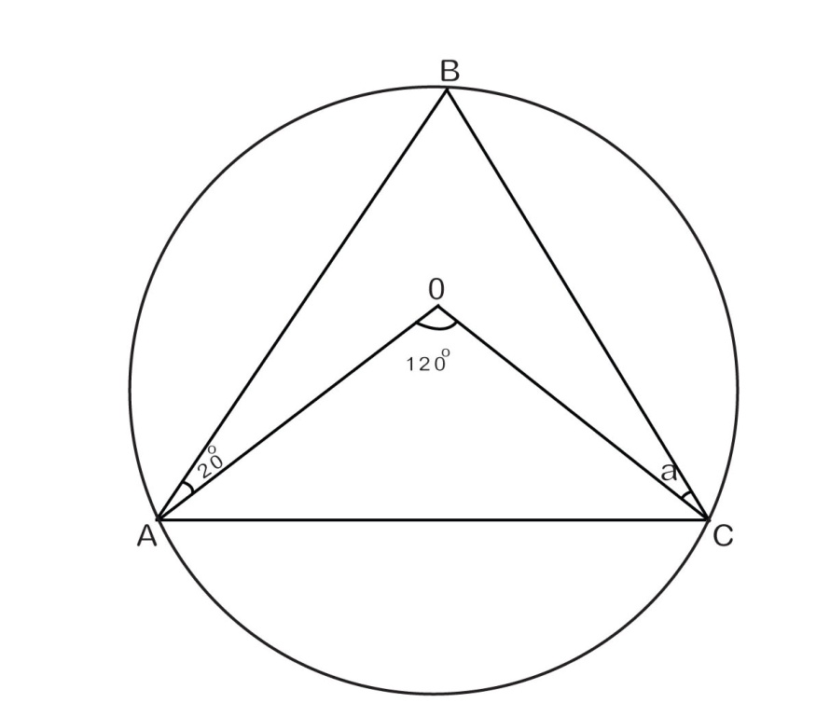

Find the size of:

1. Angle BCO marked a
2. Reflex angle AOC  **4marks**
3. The point M(5,12) is mapped onto Mˡ(-3,8) under an enlargement with centre E and scale factor -3. Using vectors, determine the coordinates of E.

**4 marks**

**SECTION B (60 MARKS)**

**ATTEMPT ONLY FIVE QUESTIONS FROM THIS SECTION**

1. a).The table below shows the masses in Kg of S4 students in Pioneer PEAS School. Copy and complete the table by using an assumed mean of 57.

|  |  |  |  |  |  |  |
| --- | --- | --- | --- | --- | --- | --- |
| MASS | FREQ  (f) | MID MARK  X | (X-A)=d | fd | c.f. | CLASS  BOUNDARY |
| 40-44 | 5 |  |  |  |  |  |
| 45-49 | 7 |  |  |  |  |  |
| 50-54 | 12 |  |  |  |  |  |
| 55-59 | 5 |  |  |  |  |  |
| 60-64 | 4 |  |  |  |  |  |
| 65-69 | 4 |  |  |  |  |  |
| 70-74 | 3 |  |  |  |  |  |
|  | $\sum{f}$ = |  |  | $\sum{fd}$ = |  |  |

1. Use your completed table to calculate the mean mass.
2. Draw a cumulative frequency curve and hence estimate the median mass

**12 marks**

1. a). Using a ruler, a pencil and a pair of compasses only:
2. Construct a triangle PQR in which $\overline{PQ}$ = $\overline{QR}$ = 6.4 cm and angle PQR = 105˚
3. Measure and state the length of $\overline{PR}$ and Angle PRQ

(b) Construct a perpendicular line from point P to meet $\overline{RQ}$ produced at N. Also locate points S on $\overline{PN}$ produced such that $\overline{PR}$ = $\overline{SR}$.

(i). measure and state the length of $\overline{PS}$

(ii). Draw an inscribed circle of the ∆PRS and hence state the radius of the circle.  **12 marks**

1. A rectangle KLMN has verticals K (1,2), L(3,2), M(3,0) and N(1,0). Rectangle KLMN is mapped onto rectangle Kˈ, Lˈ, Mˈ, Nˈ by the transformation Matrix

A= $\left(\begin{aligned}2 0 \\ 0 2\end{aligned}\right)$

a).Find the coordinates of Kˈ, Lˈ, Mˈ and Nˈ

**04marks**

b).Rectangle Kˈ Lˈ Mˈ Nˈ is then mapped onto K"L" M" N" with vertices K" (14,4), L" (18,4), M" (6,0) and N" (2,0) by Matrix B. Find the matrix of transformation B. **6 marks**

(c). Find the single transformation matrix which maps rectangle KLMN onto K" L" M" N" 2marks

1. a). The column matrix $\left(\begin{aligned}x \\ y\end{aligned}\right)$ is pre-multiplied by matrix $\left(\begin{aligned}0 4 \\ 5 ¯2\end{aligned}\right)$ to give the

Column matrix $\left(\begin{aligned}1 2 \\ 2 3\end{aligned}\right)$. Find the value of x and y. (5 marks)

b). Given matrix P= $\left(\begin{matrix}2 & 1 \\ 3 & 2\end{matrix}\right)$, Q= $\left(\begin{matrix}2 & ¯1 \\ ¯3 & 2\end{matrix}\right)$

Find:

1. Matrix PQ
2. a 2x2 Matrix R such that QR=P

**7marks**

15.a) Copy and complete the table of values of x and y for the curve y=x²-8 for

-5≤ x≤5.

|  |  |  |  |  |  |  |  |  |  |  |  |
| --- | --- | --- | --- | --- | --- | --- | --- | --- | --- | --- | --- |
| **x** | **-5** | **-4** | **-3** | **-2** | **-1** | **0** | **1** | **2** | **3** | **4** | **5** |
| **x²** |  |  |  |  |  |  |  |  |  |  |  |
| **-8** |  |  |  |  |  |  |  |  |  |  |  |
| **y** |  |  |  |  |  |  |  |  |  |  |  |

**b).** Use your table to draw a graph of y=x²-8

c) On the same axes, draw the graph of line y=3x-4

d). Use your graphs to solve the equation x²-3x-4=0

12 marks

16a). Given that a²-b² = 40 and a-b = 4, determine the value of a and b. **5marks**

**b).** Jane was sent to buy 3kg of rice and 2kg of posho and was given shs, 10,000 which was the exact cost of the quantities of the items from the shop. When she reached the shop, she got mixed up and asked the shop keeper for 2kg of rice and 3kg of posho and was given a balance of Shs. 500. Determine the cost of a kilogram of each of the items at the shop.  **7 marks**

**17.** A furniture company wishes to transport at least 600 desks from its stores to a school. It has two types of trucks A and B. Truck A can carry 50 desks at a cost of Sh. 40,000 per trip. Truck B can carry 75 desks at a cost of Shs. 50,000 per trip. There is Shs. 600,000 available for transport. The number of trips made by truck A should not exceed 7. The number of trips made by truck B should not exceed the number of trips made by truck A.

a). If x and y are the trips made by A and B respectively, write down four inequalities satisfying the given conditions. **4 marks**

b). On the same axes, draw the graphs of the inequalities and shade the unwanted regions. **5 marks**

**c).** Use your graph in (b) to determine the number of trips each truck should make so as to maximize the transport cost. Hence, find the amount of money served on transport. **3marks**

**END**